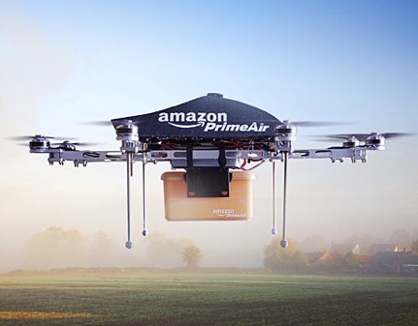**AE483 FINAL PROJECT PROPOSAL**

https://www.asme.org/getmedia/05b8b9b4-c3c1-4c1c-9a5d-977693ff773d/Developing_Delivery_Drones_hero.jpg.aspx

A. Person and B. Person

November 14, 2016

**Application**

The application motivating this project is to deliver a package (e.g., a book) from a truck to a residence with a quadcopter.

**Capability**

Package delivery requires a quadcopter to pick up a box at one location and put it down in a different location. This project will focus only on transport—moving the box from one place to another, assuming it is already attached to the quadcopter.

**Steps**

1. *Model.* Derive the equations of motion that describe the quadcopter/box system. Linearize and discretize these equations, putting them in standard form (discrete-time, state-space). Complete by Monday, November 28.
2. *Simulation*. Design and implement a controller for the quadcopter/box system near hover in MATLAB by modifying the code that the PIs (A. Person and B. Person) have developed in the AE483 homework assignments. Show that this controller enables trajectory tracking of a straight line between two points with bounded error in simulation by plotting position error as a function of time. Complete by Friday, December 2.
3. *Experiment.* Attach a box to the quadcopter in lab. Implement the same controller that worked in simulation, showing that it enables trajectory tracking of a straight line between two points with bounded error for the real quadcopter/box system by plotting position error as a function of time. Complete by Friday, December 9.

**Bonus**

Enable the quadcopter to move the box from one place to another, assuming this box is attached and detached by hand while the quadcopter is hovering.